ASSIGNMENT- 23.2
Veerla Sathvika
2303A52434
Batcch-38
Task 1 – Project Proposal
• Students choose a real-world problem to solve with an AI-
assisted application (e.g., e-commerce billing system, health
monitoring dashboard, student attendance tracker).
• Prepare a project proposal including:
o Objective
o Features
o Tools/technologies to be used
o Expected output
PROMPT:
Generate a simple project proposal for an AI-assisted application based on a real-world problem. Include:
1. Project title
2. Objective
3. Features
4. Tools/technologies to be used
5. Expected output
CODE:
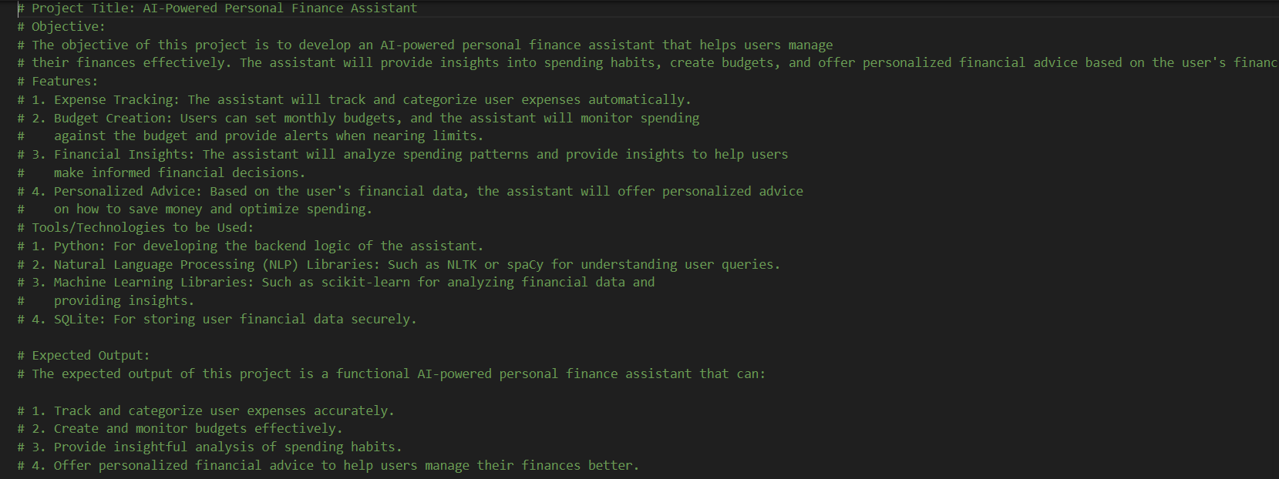
EXPLANATION:
The AI-Powered Personal Finance Assistant is a smart application designed to help users manage their money effectively. It tracks expenses, creates budgets, analyzes spending habits, and gives personalized financial advice. The project uses Python, NLP, Machine Learning, and SQLite to build an intelligent system that supports better financial planning and decision-making.
Task 2 – Application Design
• Use AI tools to assist in:
o Designing system architecture diagrams.
o Defining database schema (if needed).
o Creating wireframes/UI mockups for frontend design
PROMPT 1:
Design a simple system architecture for an AI-Powered Personal Finance Assistant. Include frontend, backend, AI analysis module, and database. Explain each component and provide a simple text-based architecture diagram.
OUTPUT:
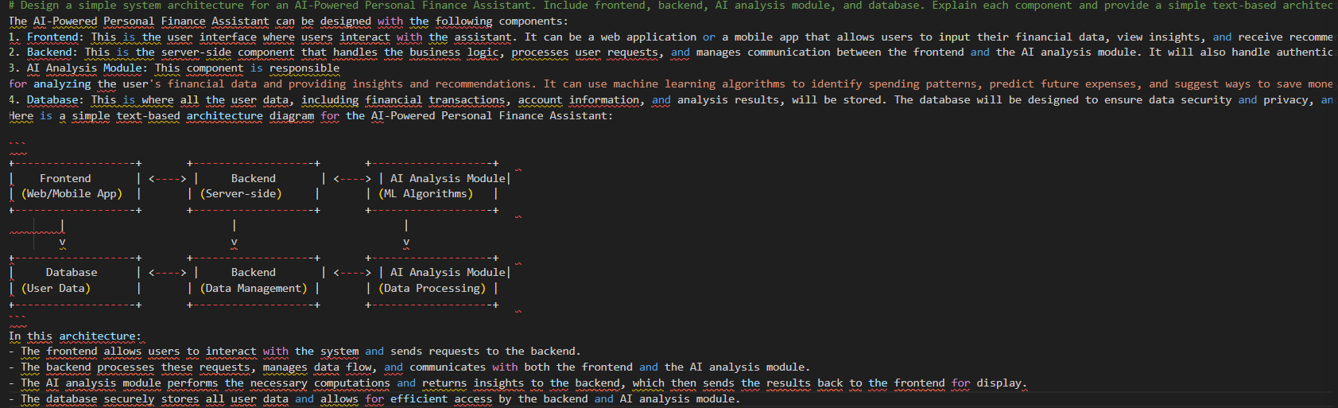
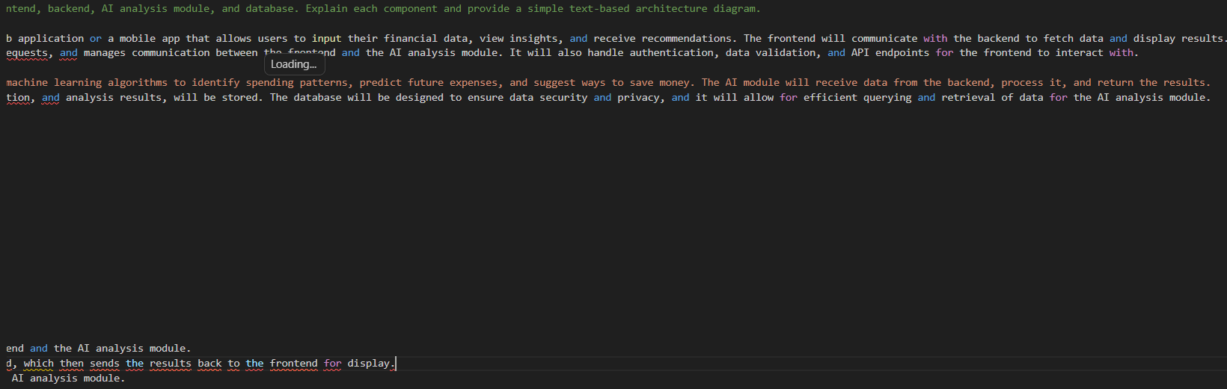
EXPLANATION:
The application is designed using four main components: frontend, backend, AI analysis module, and database. The frontend is used by the user to enter and view financial data. The backend handles system logic and communication. The AI module analyzes spending behavior and gives smart suggestions. The database stores all user and financial information. This architecture ensures smooth working of the application.

PROMPT2:
Create a simple database schema for an AI-Powered Personal Finance Assistant. Include tables like Users, Expenses, Budgets, and Financial Advice with column names, data types, and key relationships.
OUTPUT:
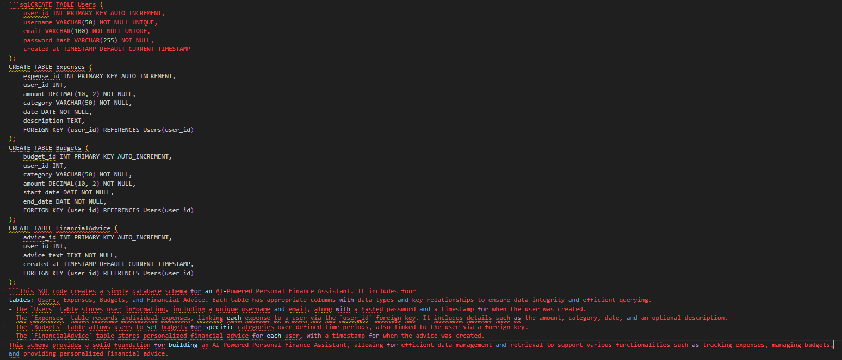
EXPLANATION:
The database schema explains how the data of the AI-Powered Personal Finance Assistant is stored and organized. It contains different tables such as Users, Expenses, and Budgets. The Users table stores basic user information like name, email, and password, while the Expenses table stores details about spending such as amount, category, date, and description. The Budgets table is used to save the budget limits set by the user. These tables are connected through user_id, which helps link each user with their own financial records. This structure makes the data well-organized, easy to access, and useful for managing the application efficiently.
PROMPT 3:
Design simple wireframes/UI mockups for an AI-Powered Personal Finance Assistant. Include pages such as Login, Dashboard, Add Expense, Budget, and Insights. Explain the UI elements on each page and provide a simple text-based layout.
OUTPUT:
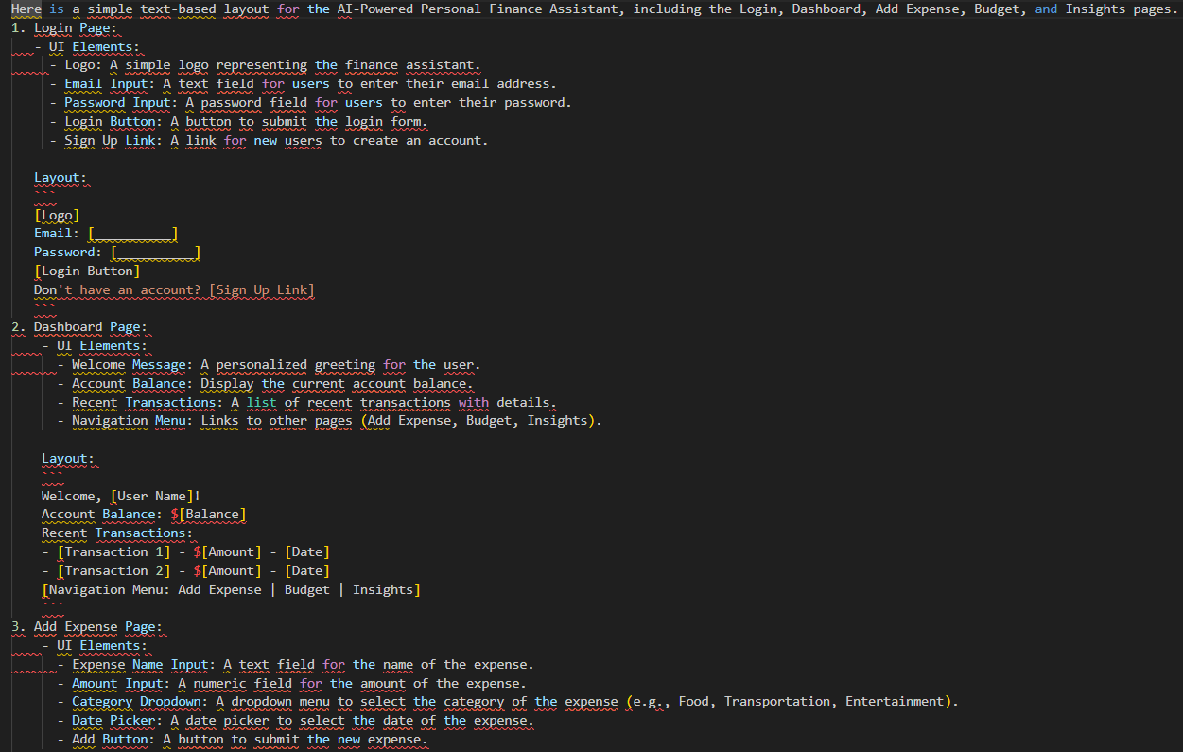
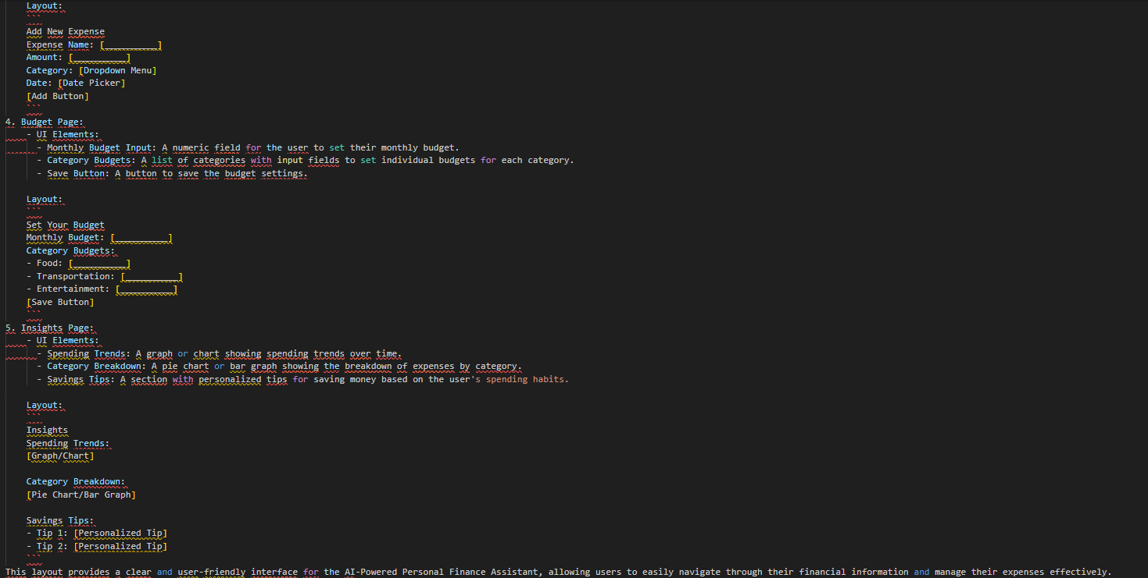
EXPLANATION:
The wireframe/UI design shows the basic layout of the AI-Powered Personal Finance Assistant application. It includes important pages such as Login, Dashboard, Add Expense, Budget, and Insights. Each page is designed with simple input fields, buttons, and sections to help users easily manage their financial data. The dashboard displays account balance and recent transactions, while other pages allow users to add expenses, set budgets, and view spending analysis. Overall, this design makes the application user-friendly, simple, and easy to navigate.

Task 3 – AI-Assisted Code Development
• Implement the application in phases:
o Frontend: Web/mobile UI with HTML/CSS/JS (or
framework).
o Backend: RESTful APIs or server logic.
o Database: Schema design, SQL queries.
o Integration: API calls, authentication, error handling
PROMPT:
Help me develop my project “AI-Powered Personal Finance Assistant” in phases.
Please provide:
1. Frontend code using HTML, CSS, and JavaScript
2. Backend code with simple REST API or server logic
3. Database schema with SQL queries
4. Integration between frontend, backend, and database
5. Basic authentication and error handling
OUTPUT:
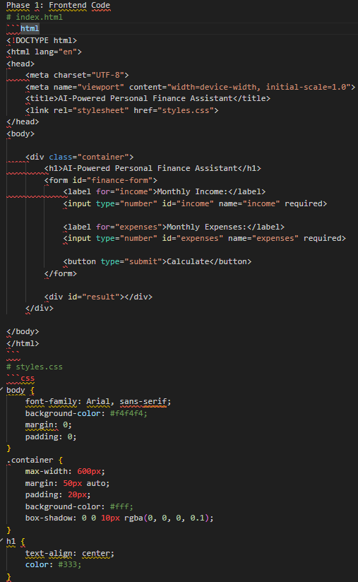

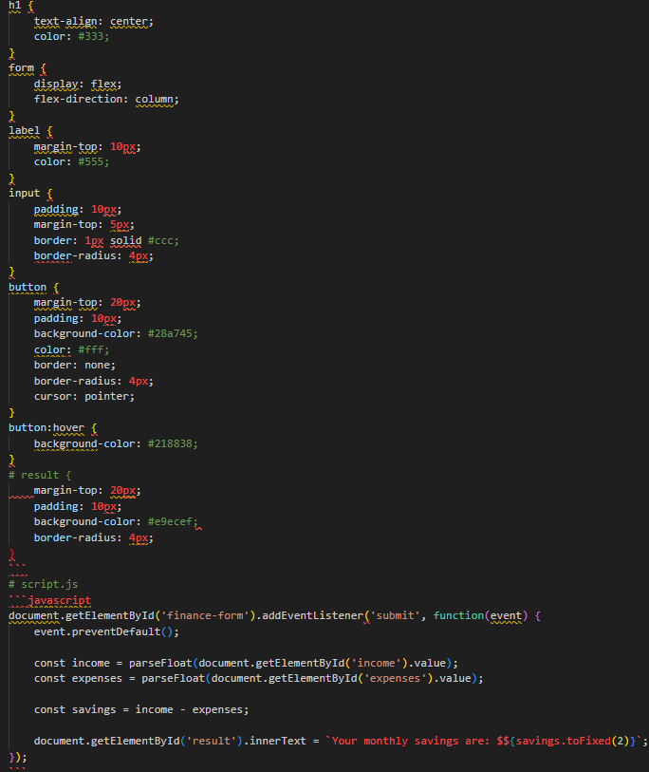
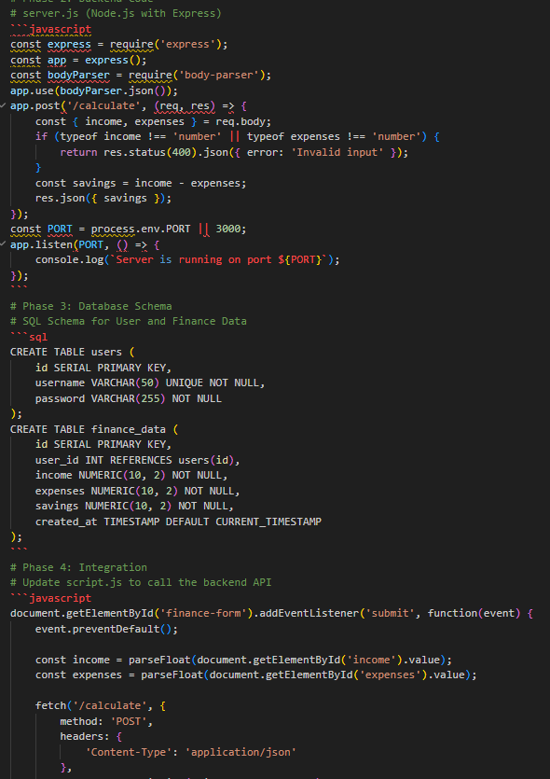
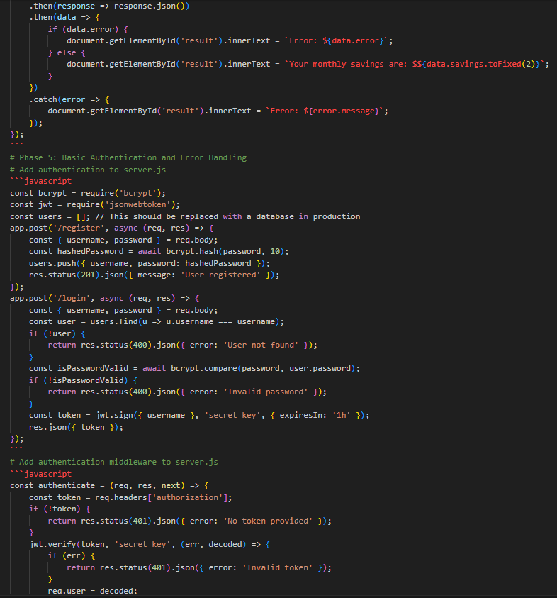
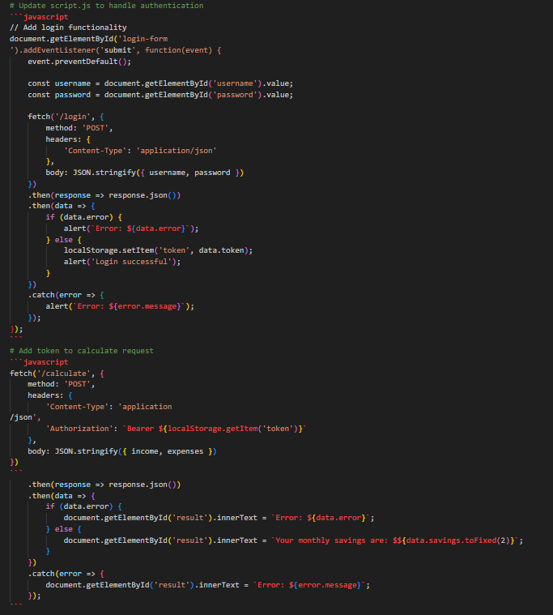
EXPLANATION:
This project is developed in five phases to make the application complete and functional. First, the frontend is created using HTML, CSS, and JavaScript to collect user income and expense details. Next, the backend is built using Node.js and Express to process the data and calculate savings. Then, the database schema is designed to store user and financial information securely. Finally, integration and authentication are added so the frontend can communicate with the backend safely, along with proper error handling for invalid inputs.
Task 4 – Documentation & Code Quality
• Generate automatic documentation and inline comments using
AI.
• Ensure clear README.md for project setup and usage.
• Conduct AI-assisted code review to refine readability and
maintainability.
PROMPT:
Help me with Task 4 – Documentation and Code Quality for my project “AI-Powered Personal Finance Assistant”.
Please provide:
1. Automatic project documentation
2. Inline comments for the code
3. A simple README.md file for project setup and usage
4. AI-assisted code review suggestions to improve readability and maintainability
OUTPUT:
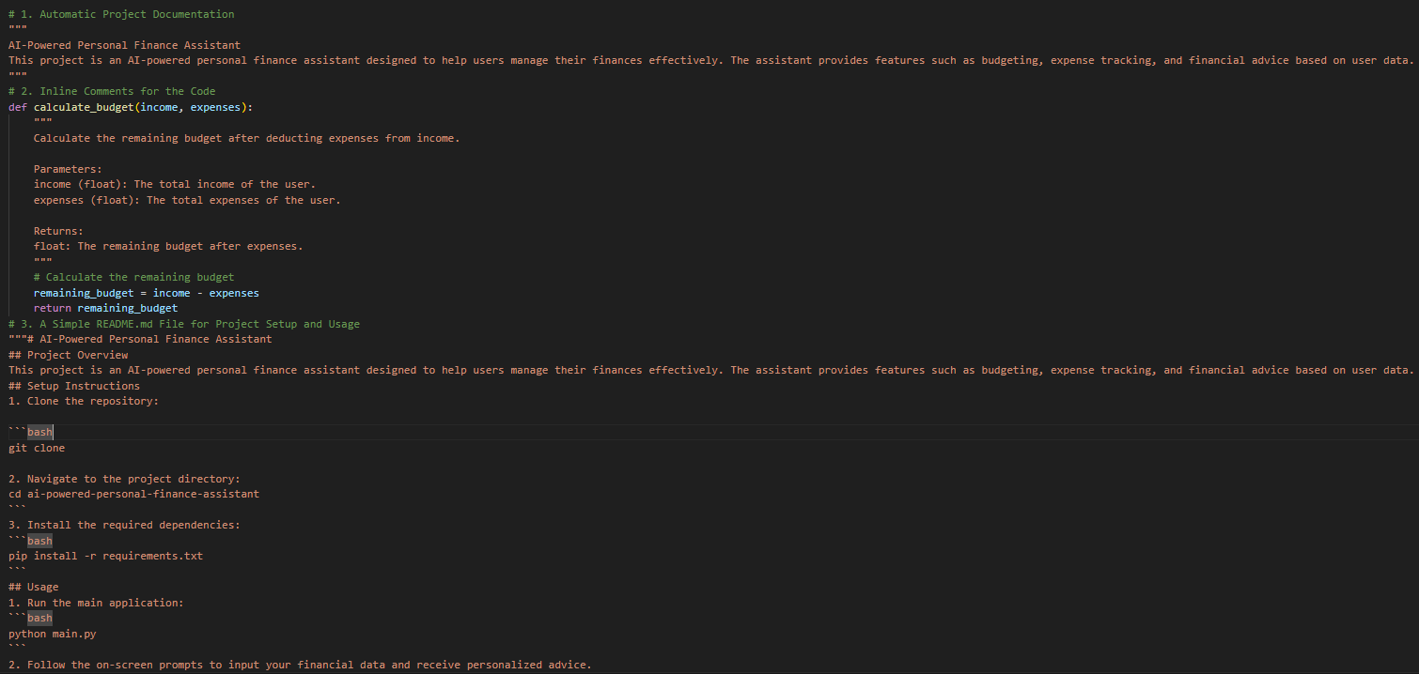
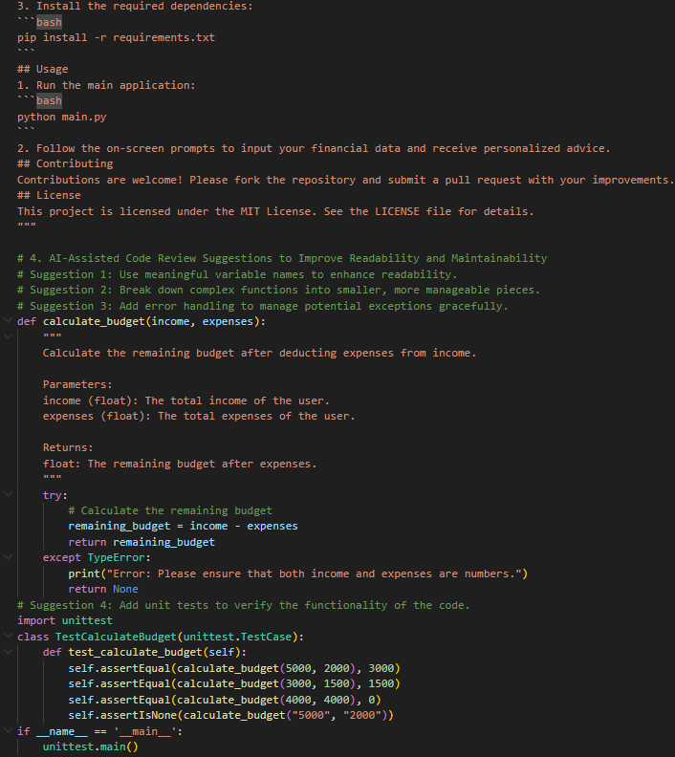
EXPLANATION:
This task focuses on improving the documentation and quality of the project code. Automatic documentation and inline comments help explain the purpose and working of the code clearly. The README.md file provides setup instructions and usage details so that anyone can run the project easily. AI-assisted code review helps improve readability, maintainability, and error handling, making the project more organized and reliable.
Task 5 – Testing & Debugging
• Use AI to:
o Generate unit tests.
o Identify vulnerabilities/security flaws.
o Suggest optimizations for performance.
PROMPT:
Help me with Task 5 – Testing and Debugging for my project “AI-Powered Personal Finance Assistant”.

Please provide:
1. Simple unit test cases for the project
2. Possible vulnerabilities or security flaws in the code
3. Suggestions to improve performance and optimization

